Final Project

F1 22 lap time analysis

Xingrui Huo xh238, Lan Cao lc1101

Why F1 22 video game analysis?

F1 is the most famous motor racing around the globe, with over 500 million views each year. The reason it gets so famous is not just cars running around the track over and over again, there is definitely something else interesting about this. Besides the different performance of each team that differs from each car, the ability of one driver to handle the car is also another interesting factor that affects the performance and eventually impacts the position of competing for the world driver’s championship. The F1 22 is the latest version of its licensed game. It includes advanced features such as realistic weather conditions, tire wear, and vehicle damage, as well as a detailed telemetry system that allows players to analyze their performance and improve their driving skills. This project attempt to do an analysis of the lap time of a specific track to see where it can be improved and where the car has reached the limit.

Preliminary Analysis

There is one article that talks about some potential factors that affect lap time.

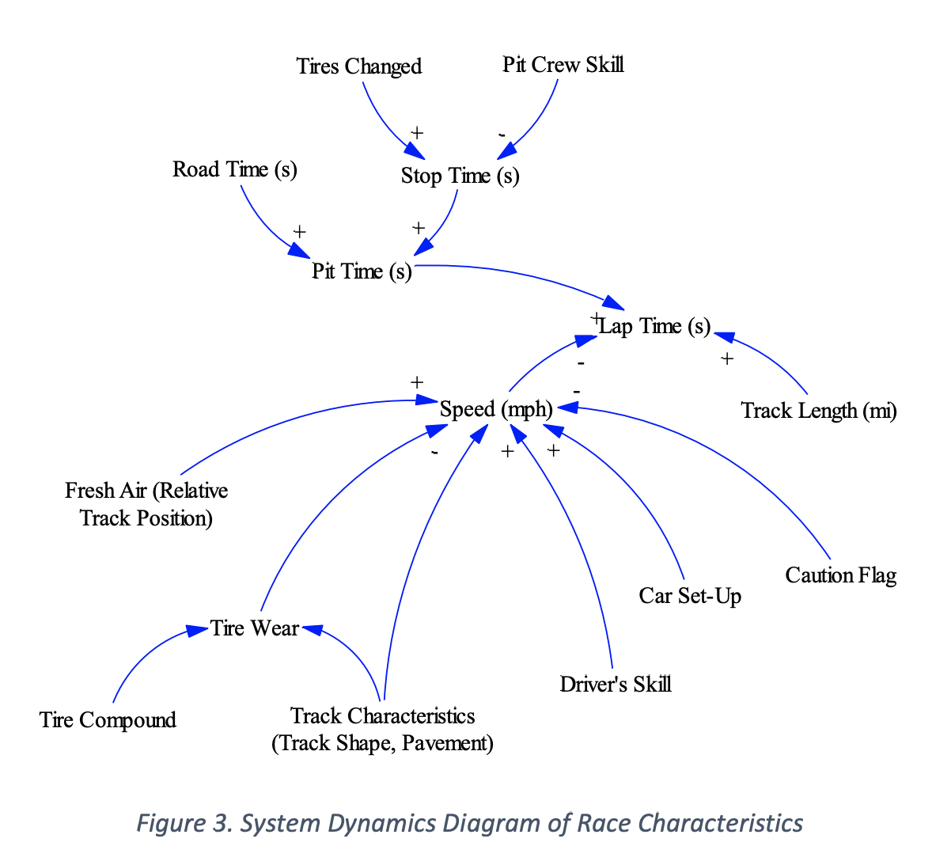 ((Ledesma and Choo 171, Fig 3, p15)

This plot detail shows what possible factors that affect lap time in the real world, and these are realistically existing. However, when it comes to game analysis, we don’t need this much of factors. Specifically, we are talking about the qualifying session in the F1 22. The qualifying session is where the car has the least negligible effect of other factors and can also demonstrate the fastest speed with the factors of human driving skills. Also is where these factors will not have an impact on the lap time. The qualifying session is where every racecar uses the softest tire and runs for one lap to get the fastest time. This means no car needs to change tires, so there is no Pit time affecting the lap time. The track and the racecar are always the same, so the track length is always the same, thus doesn’t affect the lap time. When doing the qualifying session in the game, there is only one car(which is the player) driving on the track, so there are no other cars running thus there will be no accident, so no caution flag. The car set-up is fixed at all times because there is one set-up for the car to try for the fastest lap. Since every try is only run for one lap, the tire doesn’t wear out enough to be counted toward the lap time. The game will set fresh air and track position to be optimal so that will not affect the lap time either. This will leave us with only one factor, the driver’s skill. This is also where we will take a deep dive and see how the driver’s skill 图片包含 示意图
affects the lap time.

Cleaning the Data

The original data was collected from the same car and the same track, with over 150,000 rows of data and 200 variables, this will be way too large for us to analyze.

So the first step is to narrow down the data and leaves it with only driver-related data. That narrows down the variables from 200 to 6. Lap time, lap distance, lap number, usage of throttle, brake, and steering. The lap time is to use for regression analysis. Lap distance is to use for further separation of the track. Every track in F1 is divided into three sectors to provide a more detailed and accurate analysis of a driver's performance during a lap. The sectors are used to break down the track into smaller, manageable sections, which allows for a more precise measurement of a driver's speed and performance.

Regression analysis

The regression model we choose is quadratic regression. The reason we are using this model is the three factors we are analyzing, the throttle, brake, and steering. They are not affecting the lap time independently, but also interactively. So the quadratic regression can not only evaluate the independent effect of each variable but also can evaluate the joint impact of the combination of variables.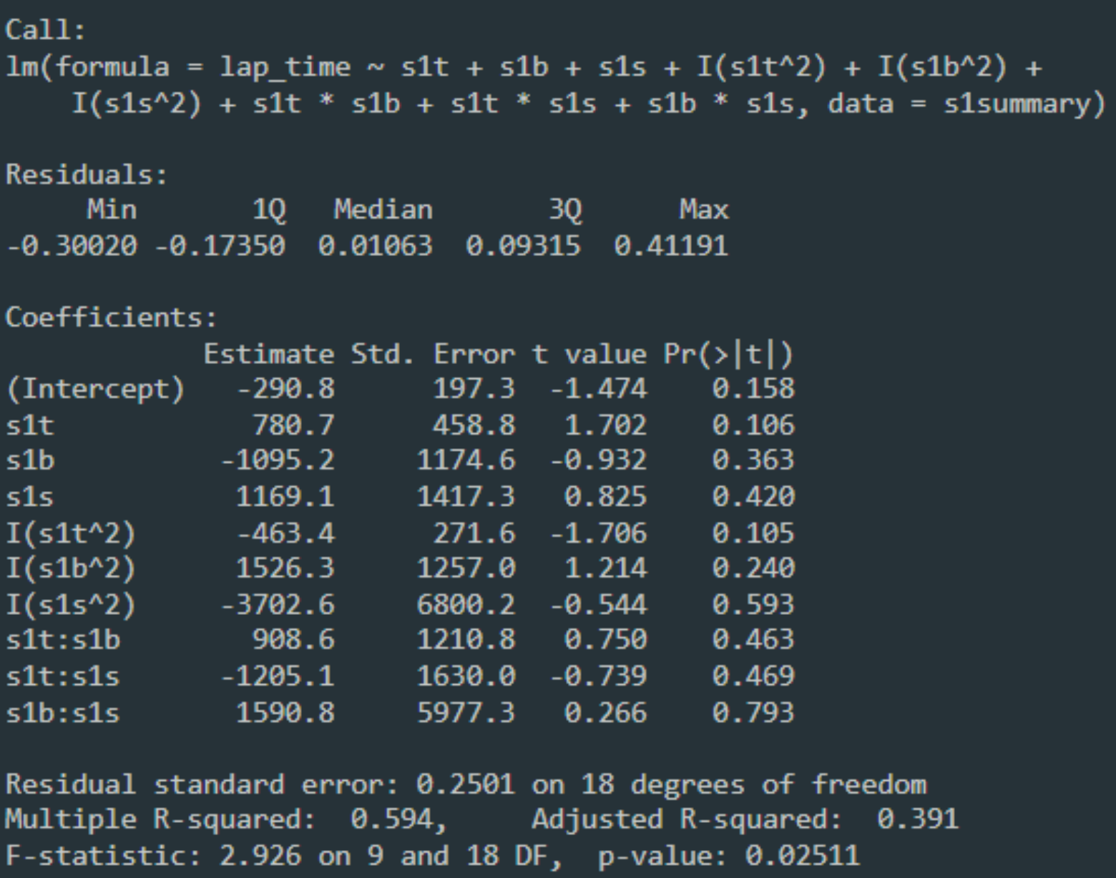

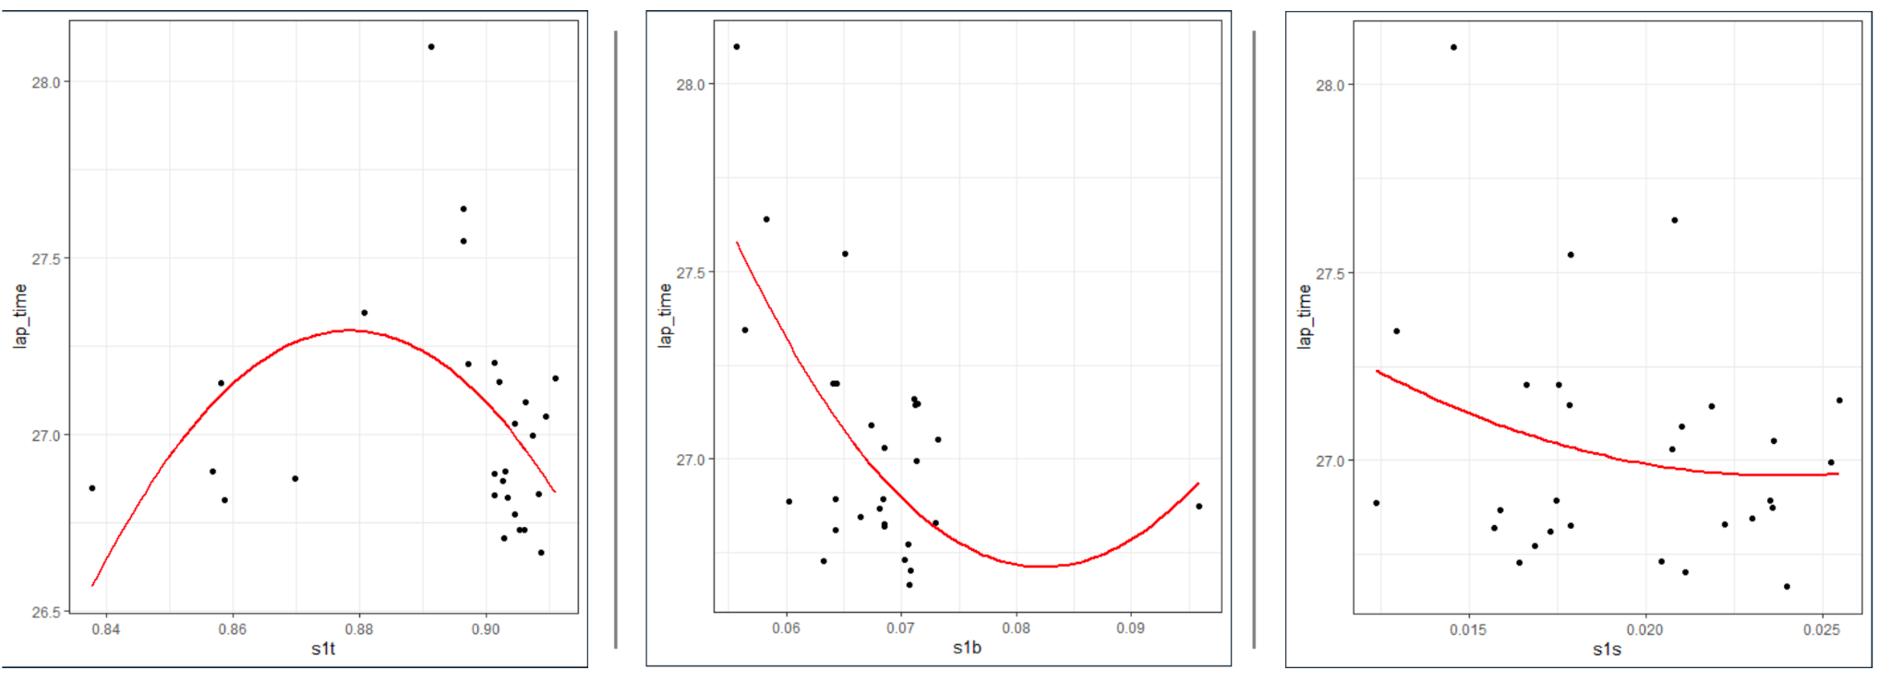

Since we are analyzing the lap time, so we should be looking for the minimum value instead of the maximum. So for the brake and steering in Sector 1, I’m pretty close to the limit. For throttle in Sector 1, there is still room to grow as I have not yet reached the lowest value of lap time. However, the throttle cannot be growing all the way to 100%. That means the car is staying in full throttle all the time and this is impossible in real life. We can also dig some information from the slope of each regression line. The slope of throttle is pretty steep, that indicates if I use the throttle 2% more, the lap time should reduce by around 0.5 seconds, which is a huge gap in terms of F1. The same applies to brake, a little bit more usage would return a huge gap. However, for the steering, there is not much improvement and also there is not much to lose. However, these are only some certain views of the regression result. We created another plot so we can see the regression and its correlation in a three-dimensional way. 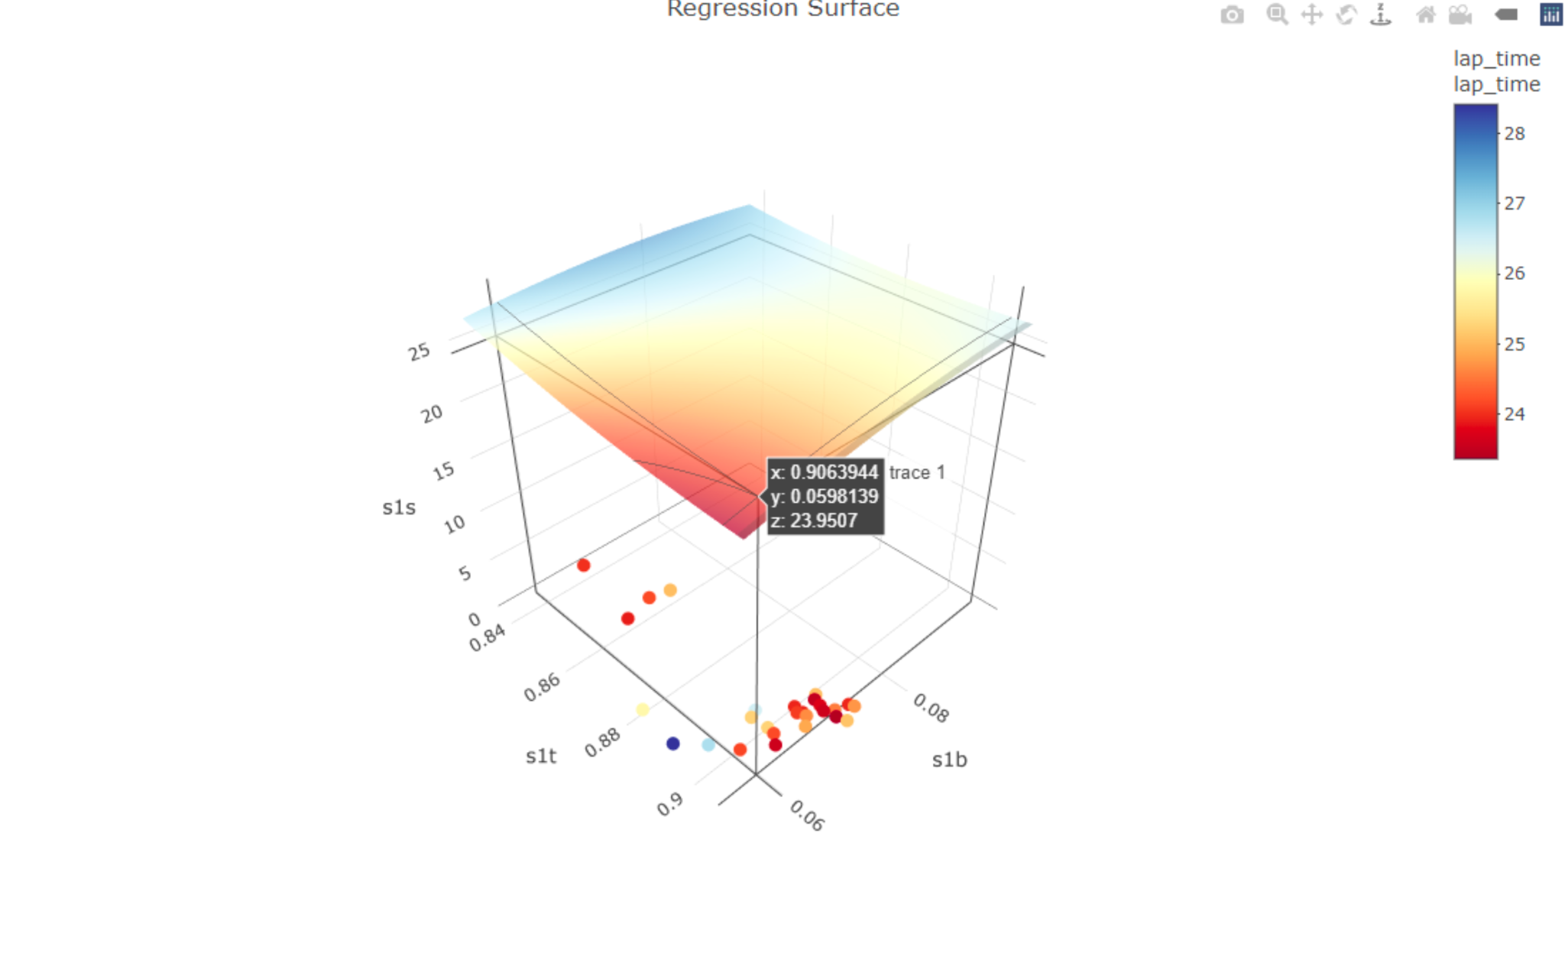

With the interactive plot, I’m able to determine which combination will give me the best lap time. My best possible prediction is somewhere around 24 to 25. This is quite convincing because the current world record in F1 22 is 23.8. So with more practice and knowledge of driving, I should be able to get reach that time level.

As for Lan, considering she is very new to the game. Her data still has a lot of room to grow.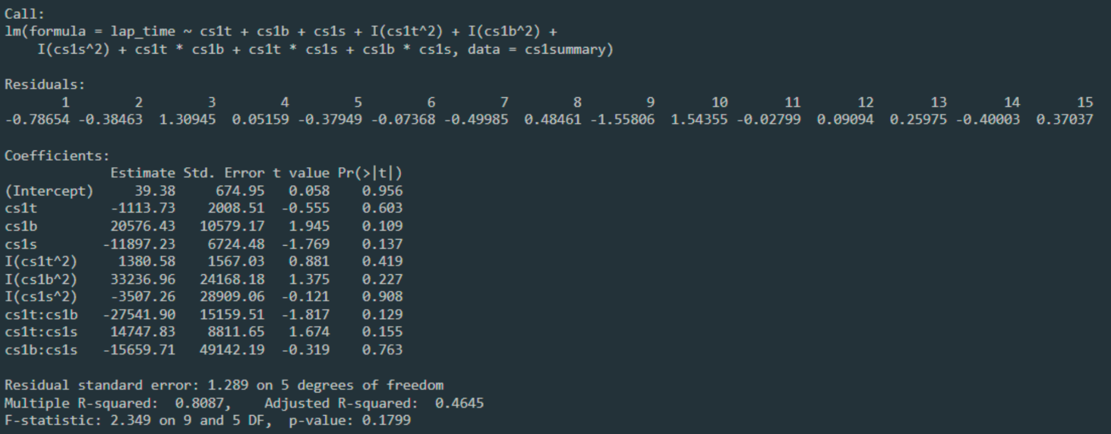 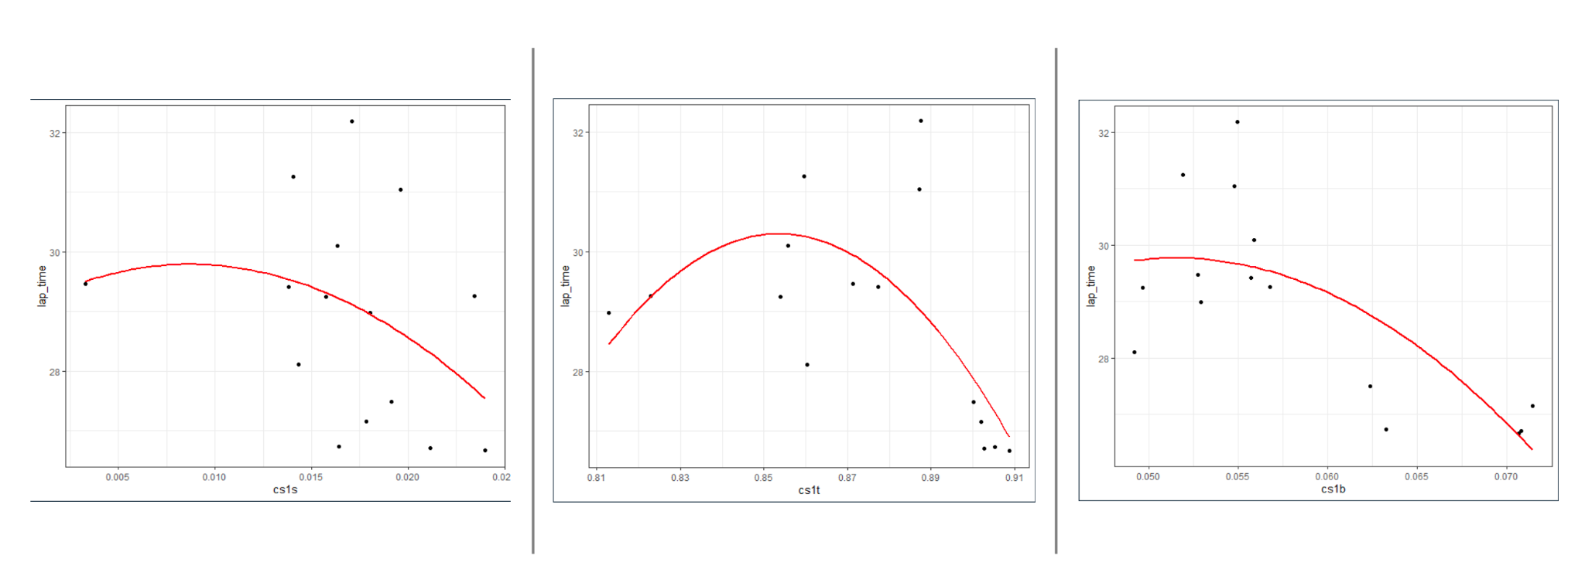

For brake and throttle, Lan uses less brake and less throttle, and the majority of her best lap is made when she is willing to press down the pedal and hard on the brake,

We still can tell from the slope of the line, the impact of throttle or brake is more significant than steering. In other words, the impact of a mistake is more acceptable than an impact of a mistake on the throttle or brake.

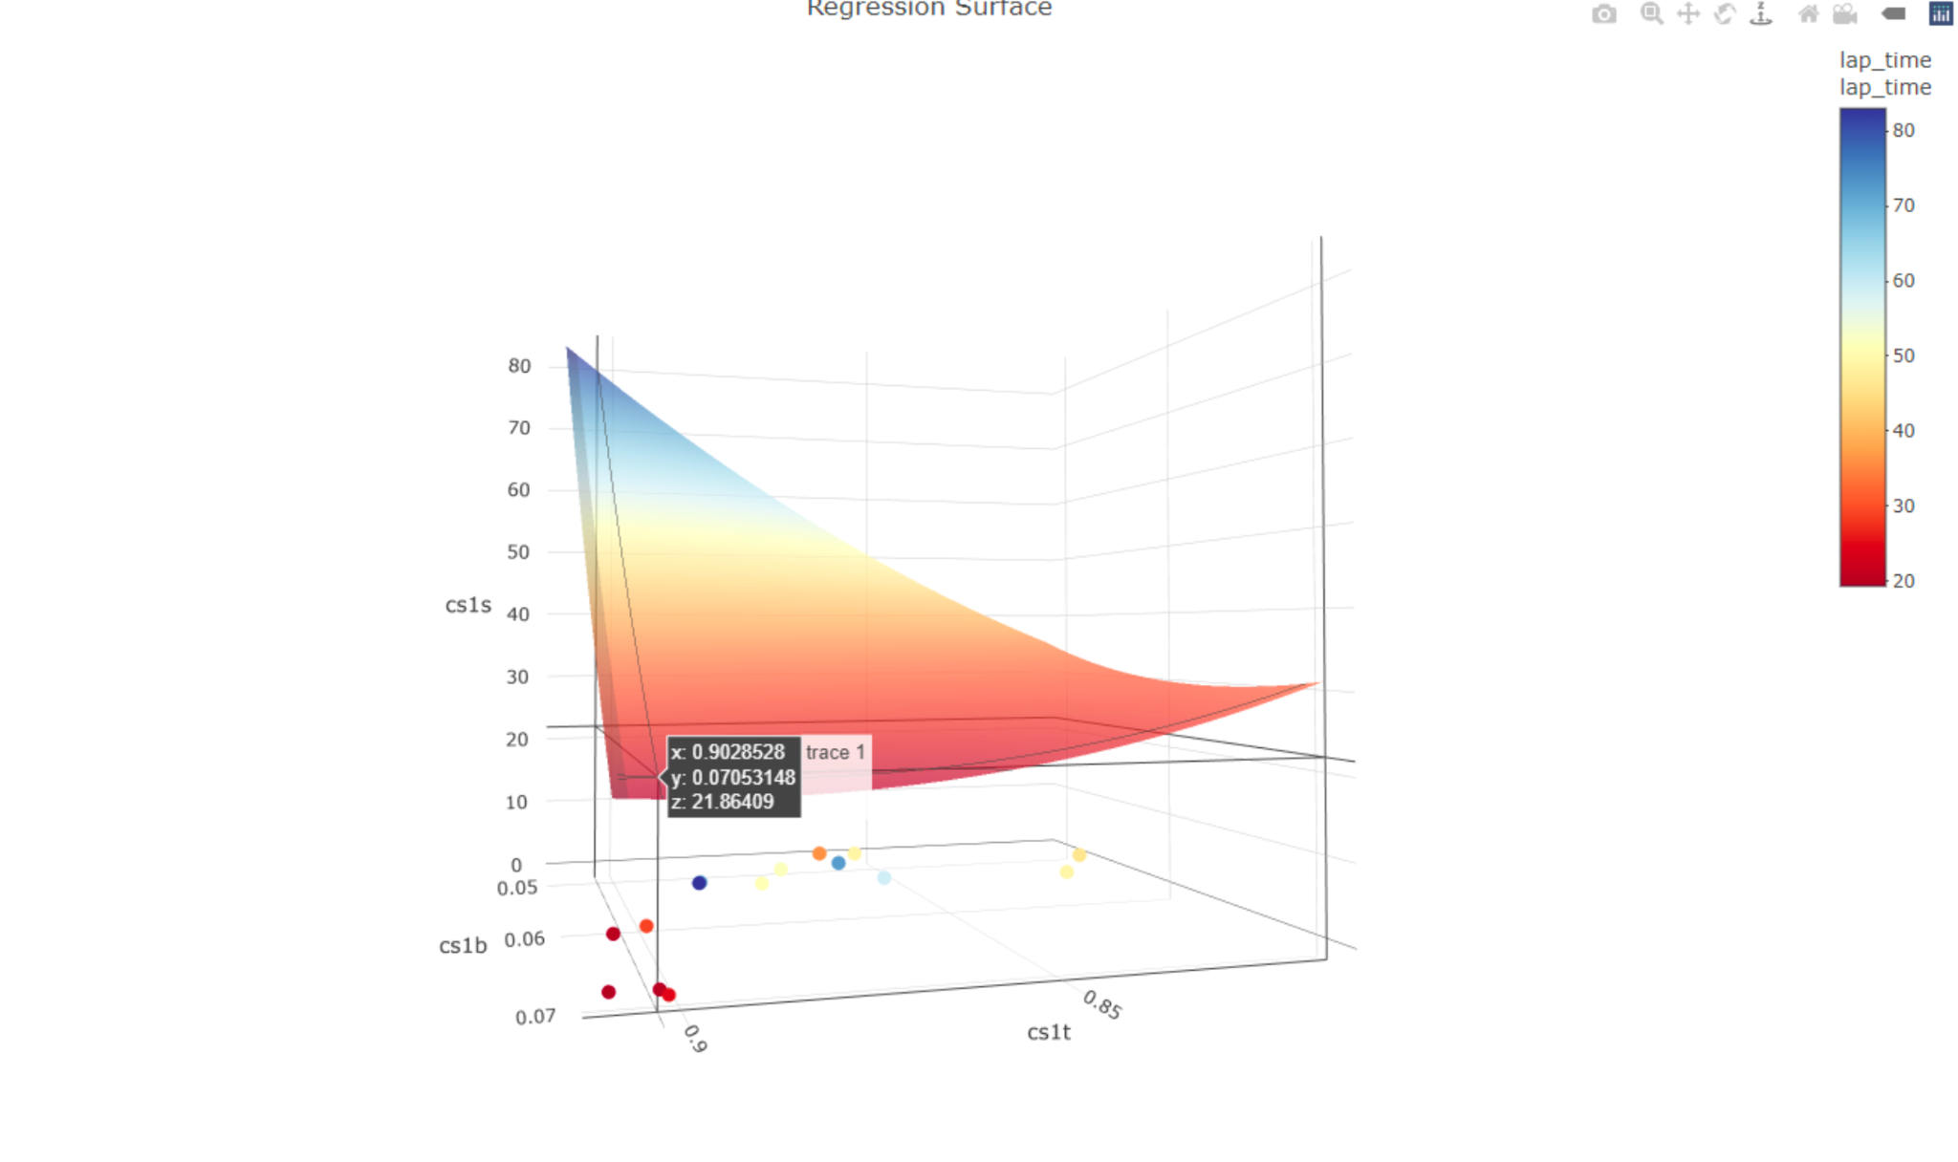

Even though Lan’s data has some gaps compared to mine, the optimal regression result is quite similar, is also somewhere around 24-26. What makes us different is the combination of throttle, brake, and steering. My combination of optimal lap requires me to use less brake but more steering. Lan’s combination is to use more brake but less steering.

Limitations

There are definitely limitations to this project. First, everything in the game is too optimized. The track condition is clean, which gives players an advantage compared to real-world drivers. There wasn’t enough lap to do a proper regression analysis. There should be more laps to make the regression statistically significant as there are already many factors being dumped which could affect the lap time significantly. The regression model we used may not be the best for predicting when it comes to putting so many factors into the function. Also, as a game, there are, undeniably, some minor differences between the track in the game and the track in the real-world, those differences will also make the gane easier than the real-world driving. This also reflects in the time difference between the e-sports and real-world data. The world record for F1 22 in Italian Grand Prix is 1:18.178 while the real world fastest lap is only 1:20.161.

Though we have conclusions that the prediction lap I had right now is what I can humanly do. However, the machine is not always right. There are countless of examples that sometimes drivers can do way better than a machine’s predication. So the machine prediction can only give us a reference, and it is on the driver to see what the real results would be.

Citation

Ledesma, Christopher, and Weisen Choo. "Real-Time Decision Making in Motorsports: Analytics for Improving Professional Car Race Strategy." Journal of Quantitative Analysis in Sports, vol. 13, no. 4, Dec. 2017, pp. 169-188. DOI: 10.1515/jqas-2016-0078.